**Time Series of Dew Point in Beijing, China**

Student’s Name:

Institutional Affiliation:

Course Number & Name:

Instructor Name:

Due Date:

**Prediction of Dew Point**

In the testing data, a time series plot was generated using the moving average technique to visualize Dew Point value trends. To measure the accuracy of the time series forecast, key metrics were calculated: the Mean Absolute Error (MAE) was approximately 3.714286, indicating an average forecast deviation of around 3.71 units; the Mean Squared Error (MSE) was about 6.612245, offering insight into the overall magnitude of forecast errors; and the Root Mean Squared Error (RMSE) was roughly 2.571429, signifying an average deviation of approximately 2.57 units between forecasted and actual Dew Point values. These metrics collectively assess the forecasting accuracy, with lower values indicating improved performance, aiding in the evaluation and potential refinement of the forecasting technique used (Kumar et al., 2023).

|  |  |
| --- | --- |
| MAE | 3.714286 |
| MSE | 6.612245 |
| RMSE | 2.571429 |

**Histogram and Frequency Table**

In the training data, the Dew Point histogram showed values ranging from -28 to 28, with peaks at bins 20-22 and 18-20, indicating concentrations there. The lowest bins (-28 to -26 and 26 to 28) had fewer values, while a roughly normal distribution was observed, centered around bins 20-22 and 18-20, providing valuable insights for central tendency and forecasting.

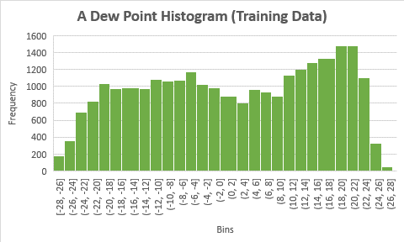

|  |  |
| --- | --- |
| **Frequency Table (Training Data)** | |
| **-28** | **72** |
| **-26** | **250** |
| **-24** | **497** |
| **-22** | **796** |
| **-20** | **954** |
| **-18** | **1003** |
| **-16** | **978** |
| **-14** | **937** |
| **-12** | **1073** |
| **-10** | **1025** |
| **-8** | **1118** |
| **-6** | **1145** |
| **-4** | **1090** |
| **-2** | **1006** |
| **0** | **886** |
| **2** | **865** |
| **4** | **813** |
| **6** | **1080** |
| **8** | **842** |
| **10** | **951** |
| **12** | **1249** |
| **14** | **1259** |
| **16** | **1269** |
| **18** | **1404** |
| **20** | **1502** |
| **22** | **1360** |
| **24** | **719** |
| **26** | **126** |
| **28** | **0** |

In the testing data, Dew Point values ranged from -40 to 26, with peaks at bins 16-18 and 14-16, indicating concentration. Conversely, bins -36 to -34, -38 to -36, and -40 to -38 had lower frequencies, suggesting infrequent low Dew Point values. The histogram showed an initial uptrend from -40 to -38 to -4 to -6, followed by a downtrend to 4 to 6, and an uptrend to 16 to 18, followed by a downtrend to 24 to 26. This suggests a cyclical pattern in Dew Point values with alternating frequency increases and decreases.

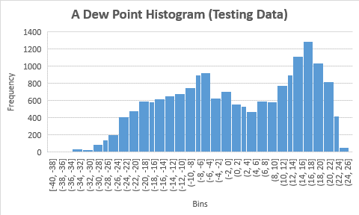

|  |  |
| --- | --- |
| **Frequency Table (Test Data)** | |
| **-40** | **2** |
| **-38** | **5** |
| **-36** | **7** |
| **-34** | **20** |
| **-32** | **25** |
| **-30** | **44** |
| **-28** | **120** |
| **-26** | **160** |
| **-24** | **290** |
| **-22** | **467** |
| **-20** | **520** |
| **-18** | **574** |
| **-16** | **624** |
| **-14** | **610** |
| **-12** | **709** |
| **-10** | **677** |
| **-8** | **844** |
| **-6** | **937** |
| **-4** | **740** |
| **-2** | **663** |
| **0** | **644** |
| **2** | **534** |
| **4** | **530** |
| **6** | **528** |
| **8** | **548** |
| **10** | **644** |
| **12** | **880** |
| **14** | **951** |
| **16** | **1263** |
| **18** | **1209** |
| **20** | **876** |
| **22** | **689** |
| **24** | **166** |
| **26** | **0** |

**Pattern Detection**

The cyclical pattern observed in Dew Point values in Beijing, China, likely stems from a combination of seasonal and meteorological factors. Beijing experiences distinct seasons, with humidity levels typically varying as a result. Seasonal shifts, such as the East Asian monsoon bringing moist air during summer months and drier conditions during winter, can contribute to the observed uptrends and downtrends (Verheyen & Bourouiba, 2022).

**Conclusion**

The analysis reveals that in the testing data, time series forecasting using the moving average technique produced moderate forecasting accuracy with a Mean Absolute Error (MAE) of approximately 3.71 units, Mean Squared Error (MSE) indicating the magnitude of errors, and a Root Mean Squared Error (RMSE) of around 2.57 units. Lower error values are desirable for improved forecasting. Additionally, the training data exhibited a Dew Point concentration around bins 20-22 and 18-20, displaying a roughly normal distribution, while the testing data showed cyclicality in Dew Point values, possibly influenced by seasonal and meteorological factors in Beijing, China.

**Reference**

Kumar, V., Kedam, N., Sharma, K. V., Mehta, D. J., & Caloiero, T. (2023). Advanced Machine Learning Techniques to Improve Hydrological Prediction: A Comparative Analysis of Streamflow Prediction Models. *Water*, *15*(14), 2572.

Verheyen, C. A., & Bourouiba, L. (2022). Associations between indoor relative humidity and global COVID-19 outcomes. *Journal of the Royal Society Interface*, *19*(196), 20210865.